Research Question

1. What are the variables that affect hotel reservation cancelation?
2. How can we make Hotel Reservation Better?
3. How will hotels be assisted in making pricing and promotional decisions?

Hypothesis

1. More cancellation occurs when price are low.
2. When they are wait for long period of time customers tend to cancel frequently.
3. The majority of clients are coming from offline travel agents to make there reservation.

Analysis and Findings

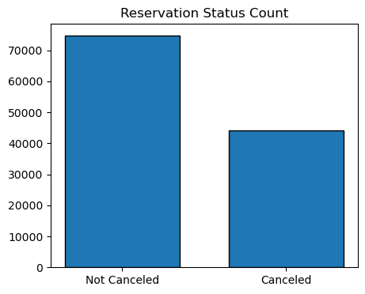

Above bar graph we can see how many percentages of people canceled and not canceled the

Reservation. Not canceled percentage is higher then canceled percentage but 37% of people cancel the reservation which is also high which also impact hotel earnings.

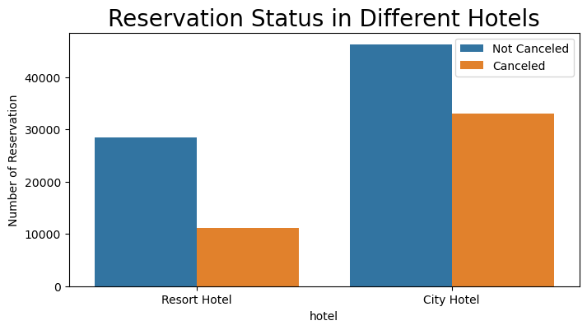

If we compare both the graph, we can see city hotel reservation more compared to resort hotel. It means may be price high in resort hotel more.

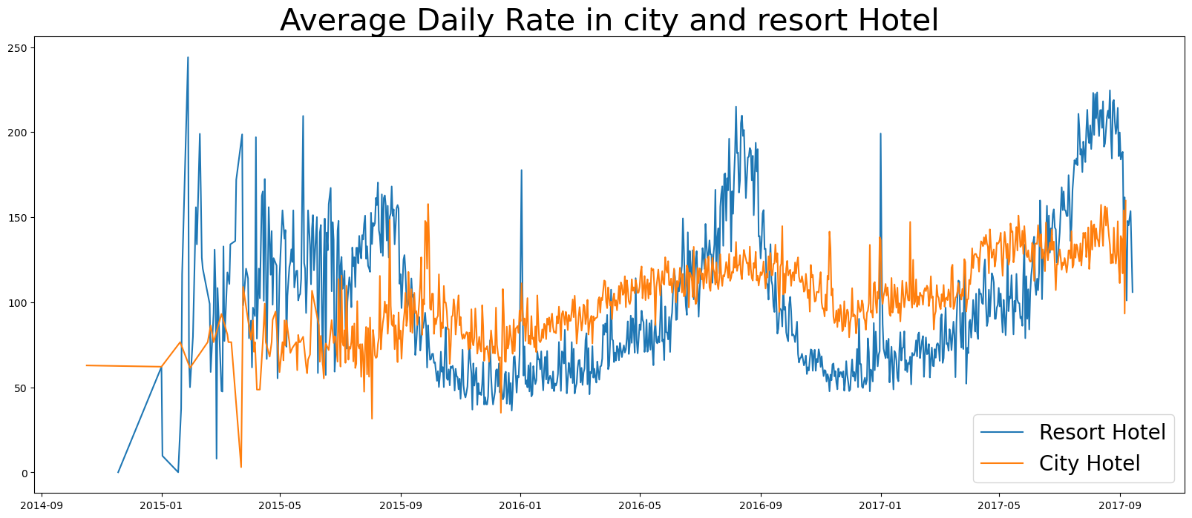

Above line graph we can see that on certain days avg daily rate for city hotel is less than resort hotel and other days even less. We may say weekends or holidays resort hotel avg rate rise.

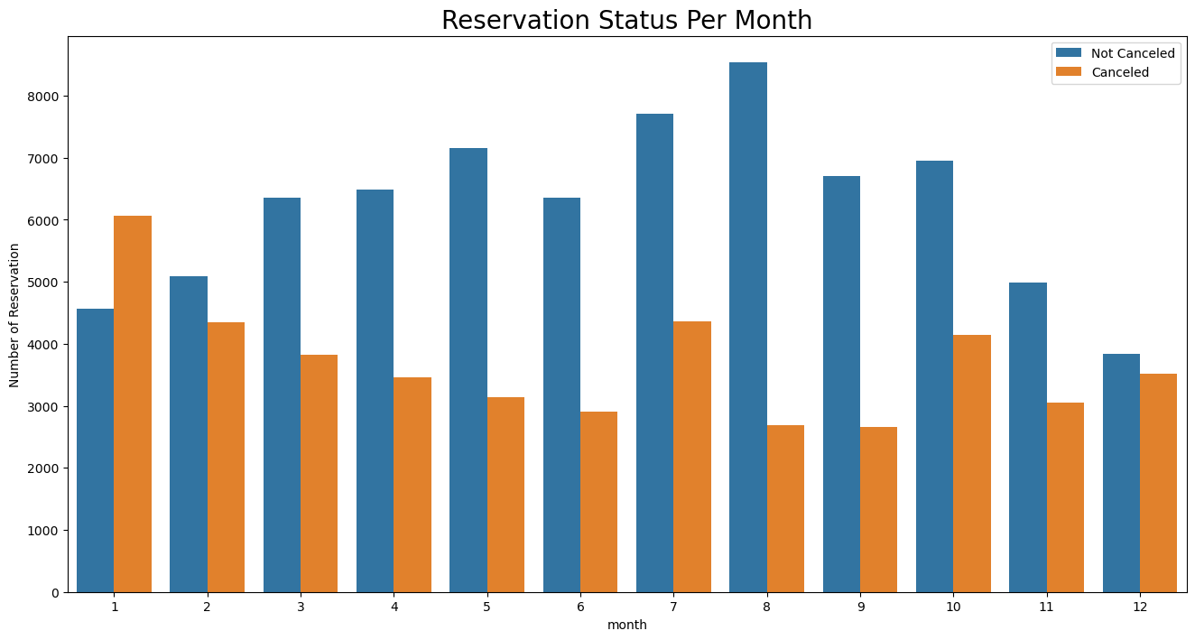

We generate a grouped bar chart to compare monthly highest and lowest cancelation according to reservation status. In the above bar graph we can see august month less canceled reservation and January month is the highest canceled reservation.

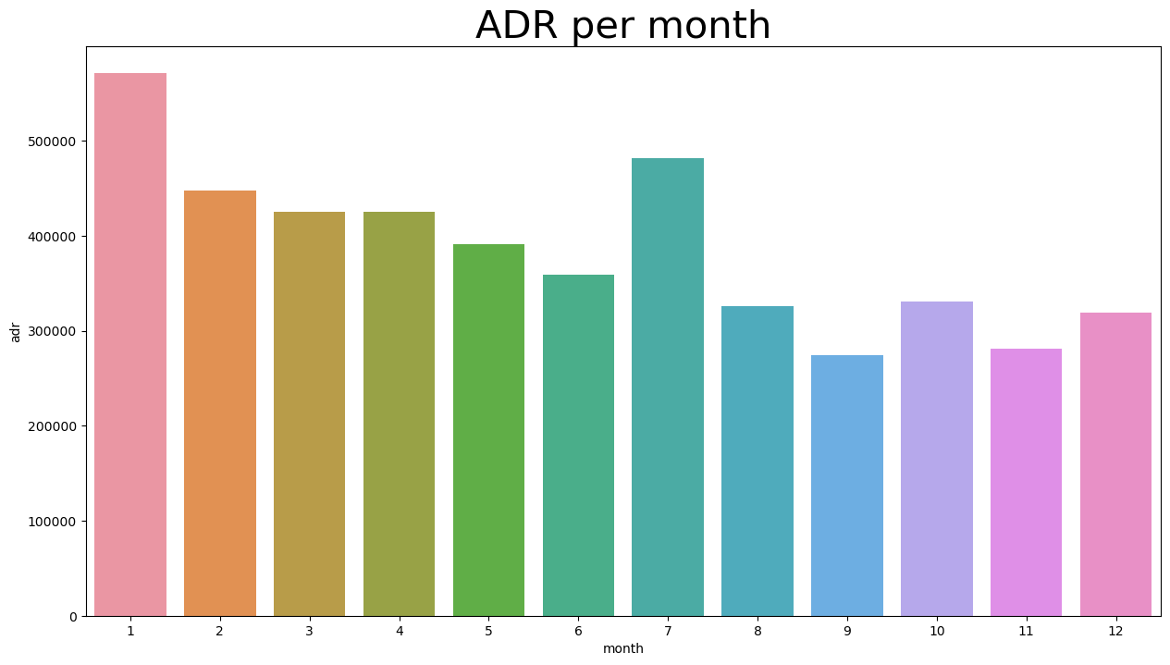

We generate ADR per month through which we can see august month price is low so cancelation low and January month price are high so high cancelation. We can say that higher price can cause of high cancelation.

Now lets see which country has the highest cancelation. The top country partugal with highest cancelation.

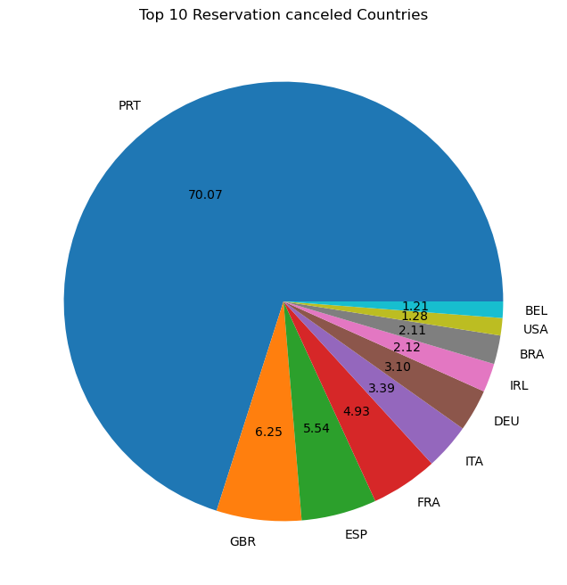

Lets check the area from where guests are visiting the hotels and making reservations. Is coming from Direct, group, offline or online travel agency? around 46 % come from online, 27% come from groups and only 4% client come from Direct for making reservation.

Below line graph reservation canceled when avg daily rate higher then when it is not canceled.

Above analysis clearly prove higher price leads to higher cancelation.

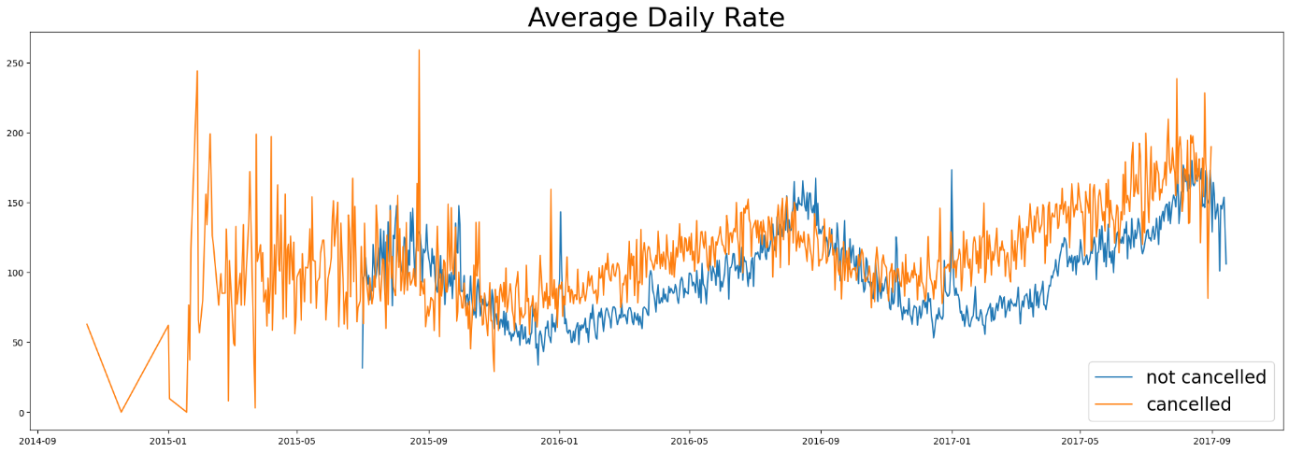

Suggestions

1. Cancellation rate rise when price rise. To avoid cancellation rate hotel should work on there pricing strategy for specific hotels based on locations. Also give some discount to the customers.
2. As Resort hotel cancellation and not cancellation is high than city hotel. They should gave some

Discount on rooms on weekend and Holidays.

1. Month of January hotel start marketing with reasonable amount to increase there Revenue.
2. They can also increase the quality of hotel and services specially in partugal to reduce the rate of cancellation